The Digestive System

Say Thanks to the Authors
Click http://www.ck12.org/saythanks
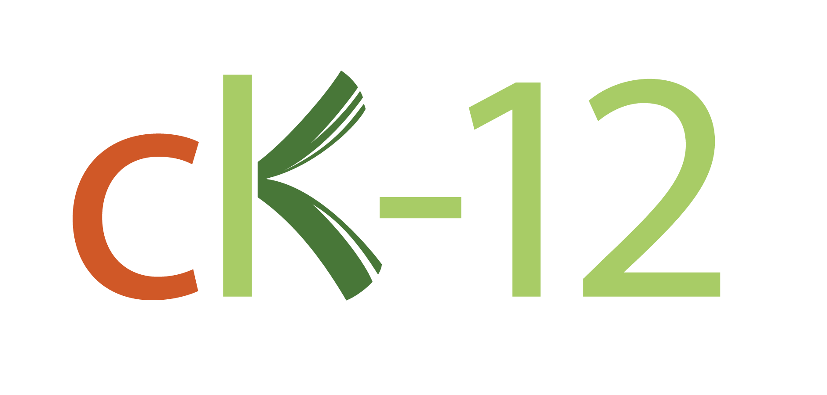

CHAPTER
1
The Digestive System

Lesson Objectives

•Identify the organs and functions of the digestive system.
•Outline the roles of the mouth, esophagus, and stomach in digestion.
•Explain how digestion and absorption occur in the small intestine.
•List functions of the large intestine.
•Identify classes of nutrients and their functions in the human body.

Vocabulary

•absorption
•bile
•body mass index (BMI)
•chemical digestion
•digestion
•digestive system
•elimination
•esophagus
•feces
•gall bladder
•gastrointestinal (GI) tract
•large intestine
•liver
•macronutrient
•mechanical digestion
•micronutrient
•mineral
•nutrient
•peristalsis
•small intestine
•stomach
•villi
•vitamin

Introduction

The respiratory and circulatory systems work together to provide cells with the oxygen they need for cellular respiration. Cells also need glucose for cellular respiration. Glucose is a simple sugar that comes from the food we eat. To get glucose (monosaccharides) from food, digestion must occur. This process is carried out by the digestive system.

The Start of Digestion: Mouth to Stomach

Does the sight or aroma of your favorite food make your mouth water? When this happens, you are getting ready for digestion.

Mouth

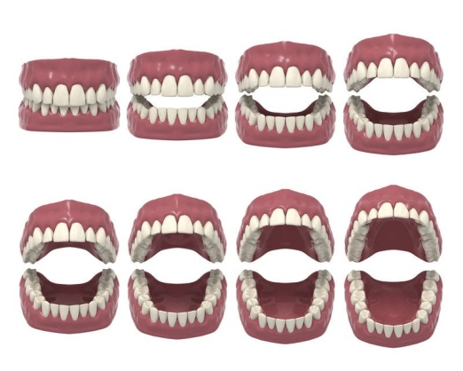
The mouth is the first digestive organ that food enters. The sight, smell, or taste of food stimulates the release of digestive enzymes by salivary glands inside the mouth. The major salivary enzyme is amylase. It begins the chemical digestion of carbohydrates by breaking down starch into sugar.

The mouth also begins the process of mechanical digestion. Sharp teeth in the front of the mouth cut or tear food when you bite into it (see Figure 1.1). Broad teeth in the back of the mouth grind food when you chew. Food is easier to chew because it is moistened by saliva from the salivary glands. The tongue helps mix the food with saliva and also helps you swallow. After you swallow, the chewed food passes into the pharynx.

FIGURE 1.1
Teeth are important for mechanical digestion.

Esophagus
From the pharynx, the food moves into the esophagus. The esophagus is a long, narrow tube that passes food from the pharynx to the stomach by peristalsis. The esophagus has no other digestive functions. At the end of the esophagus, a muscle called a sphincter controls the entrance to the stomach. The sphincter opens to let food into the stomach and then closes again to prevent food from passing back into the esophagus.

Stomach
The stomach is a sac-like organ in which food is further digested both mechanically and chemically. (To see an animation of how the stomach digests food, go to the link below.) Churning movements of the stomach’s thick, muscular walls complete the mechanical breakdown of food. The churning movements also mix food with digestive fluids secreted by the stomach. One of these fluids is hydrochloric acid. It kills bacteria in food and gives the stomach the low pH needed by digestive enzymes that work in the stomach. The main enzyme is pepsin, which chemically digests protein.
The stomach stores the partly digested food until the small intestine is ready to receive it. When the small intestine is empty, a sphincter opens to allow the partially digested food to enter the small intestine.

Digestion and Absorption: The Small Intestine
The small intestine is a narrow tube about 7 meters (23 feet) long in adults. It is the site of most chemical digestion and virtually all absorption. The small intestine consists of three parts: the duodenum, jejunum, and ileum.

Digestion in the Small Intestine
The duodenum is the first and shortest part of the small intestine. Most chemical digestion takes place here, and many digestive enzymes are active in the duodenum (see Table 1.1). Some are produced by the duodenum itself. Others are produced by the pancreas and secreted into the duodenum.
TABLE 1.1: Digestive Enzymes Active in the Duodenum
Enzyme | What It Digests | Where It Is Made
Amylase | carbohydrates | pancreas
Trypsin | proteins | pancreas
Lipase | lipids | pancreas, duodenum
Maltase | carbohydrates | duodenum
Peptidase | proteins | duodenum

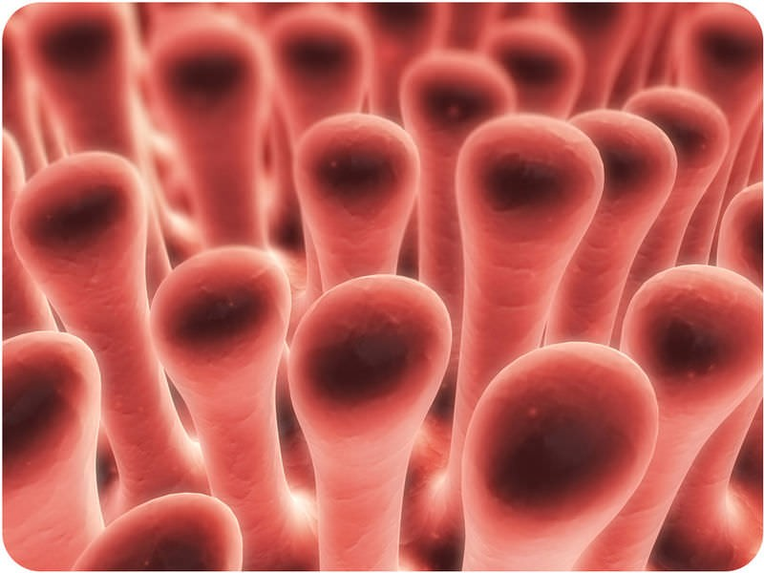
The liver is an organ of both digestion and excretion. It produces a fluid called bile, which is secreted into the duodenum. Some bile also goes to the gall bladder, a sac-like organ that stores and concentrates bile and then secretes it into the small intestine. In the duodenum, bile breaks up large globules of lipids into smaller globules that are easier for enzymes to break down. Bile also reduces the acidity of food entering from the highly acidic stomach. This is important because digestive enzymes that work in the duodenum need a neutral environment. The pancreas contributes to the neutral environment by secreting bicarbonate, a basic substance that neutralizes acid.

Absorption in the Small Intestine
The jejunum is the second part of the small intestine, where most nutrients are absorbed into the blood. As shown in Figure 1.2, the mucous membrane lining the jejunum is covered with millions of microscopic, fingerlike projections called villi (singular, villus). Villi contain many capillaries, andnutrients pass from the villi into the bloodstream through the capillaries. Because there are so many villi, they greatly increase the surface area for absorption. In fact, they make the inner surface of the small intestine as large as a tennis court!
Fig. 1.2 Villi are actually microscopic, they are enlarged here.

The ileum is the third part of the small intestine. A few remaining nutrients are absorbed here. Like the jejunum, the inner surface of the ileum is covered with villi that increase the surface area for absorption.

The Large Intestine and Its Functions

From the small intestine, any remaining food wastes pass into the large intestine. The large intestine is a relatively wide tube that connects the small intestine with the anus. Like the small intestine, the large intestine also consists of three parts: the cecum (or caecum), colon, and rectum.

Absorption of Water and Elimination of Wastes

The cecum is the first part of the large intestine, where wastes enter from the small intestine. The wastes are in a liquid state. As they passes through the colon, which is the second part of the large intestine, excess water is absorbed. The remaining solid wastes are called feces. Feces accumulate in the rectum, which is the third part of the large intestine. As the rectum fills, the feces become compacted. After a certain amount of feces accumulate, they are eliminated from the body. A sphincter controls the anus and opens to let feces pass through.

Bacteria in the Large Intestine

Trillions of bacteria normally live in the large intestine. Most of them are helpful. In fact, we wouldn’t be able to survive without them. Some of the bacteria produce vitamins, which are absorbed by the large intestine. Other functions of intestinal bacteria include:

•Controlling the growth of harmful bacteria.
•Breaking down indigestible food components.
•Producing substances that help prevent colon cancer.
•Breaking down toxins before they can poison the body.

