Introduction to Soils
Introduction
Without mechanical and chemical weathering working to break down rock, there would not be any soil on Earth. It is unlikely that humans or most other creatures would be able to live on Earth without soil. Wood, paper, cotton, medicines, and even pure water need soil. So soil is a precious resource that must be carefully managed and cared for. Although soil is a renewable resource, its renewal takes a lot of time.
Characteristics of Soil

Even though soil is only a very thin layer on Earth’s surface over the solid rocks below, it is the where the atmosphere, hydrosphere, biosphere, and lithosphere meet. Within the soil layer, important reactions between solid rock, liquid water, air, and living things take place. Soil is a complex mixture of different materials.
•About half of most soils are inorganic materials, such as the products of weathered rock, including pebbles, sand, silt, and clay particles.
•About half of all soils are organic materials, formed from the partial breakdown and decomposition of plants and animals. The organic materials are necessary for a soil to be fertile. The organic portion provides the nutrients, such as nitrogen, needed for strong plant growth.
•In between the solid pieces, there are tiny spaces filled with air and water.

In some soils, the organic portion could be missing, as in desert sand. Or a soil could be completely organic, such as the materials that make up peat in a bog or swamp ( Figure 1.1).

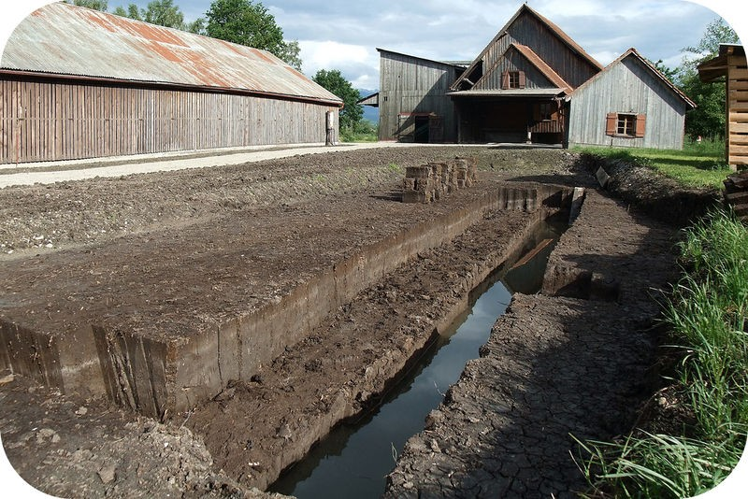
FIGURE 1.1
Peat is so rich in organic material, it can be
burned for energy.

Soil Ecosystems

Soil is an ecosystem unto itself. In the spaces of soil, there are thousands or even millions of living organisms. Those organisms could be anything from earthworms, ants, bacteria, or fungi ( Figure 1.2).
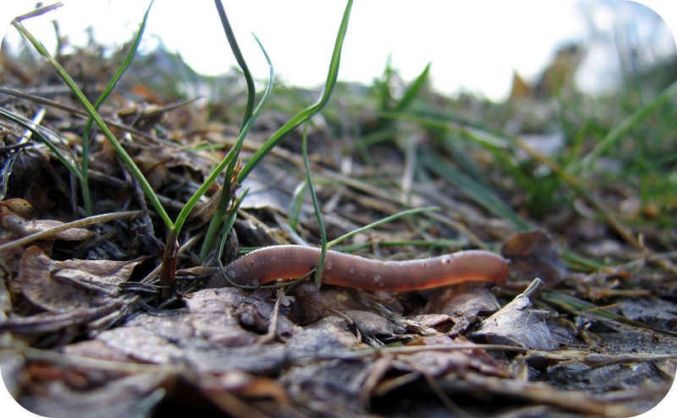

FIGURE 1.2
Earthworms and insects are important residents of soils.

Soil Horizons and Profiles

A residual soil forms over many years, as mechanical and chemical weathering slowly change solid rock into soil. The development of a residual soil may go something like this.

1.The bedrock fractures because of weathering from ice wedging or another physical process. 2.Water, oxygen, and carbon dioxide seep into the cracks to cause chemical weathering.
3.Plants, such as lichens or grasses, become established and produce biological weathering. 4.Weathered material collects until there is soil.
5.The soil develops soil horizons, as each layer becomes progressively altered. The greatest degree of weathering is in the top layer. Each successive, lower layer is altered just a little bit less. This is because the first place where water and air come in contact with the soil is at the top.

A cut in the side of a hillside shows each of the different layers of soil. All together, these are called a soil profile (
Figure 1.5).
The simplest soils have three horizons, top soil, subsoil and bed rock.
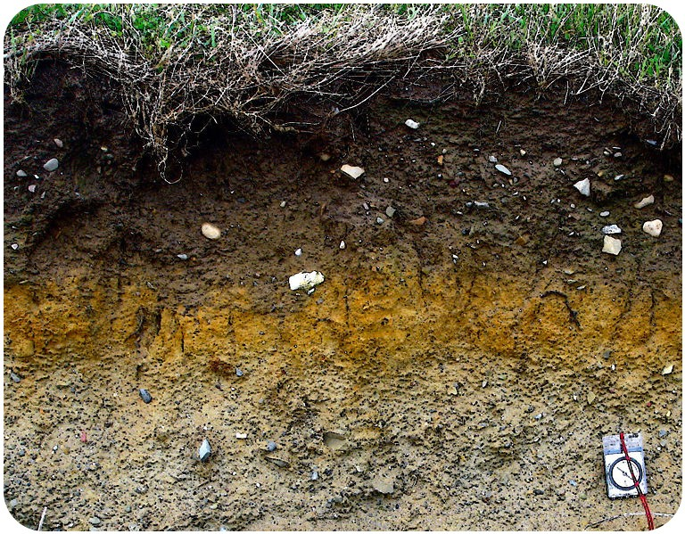

FIGURE 1.5
Soil is an important resource. Each soil horizon is distinctly visible in this photograph.

Topsoil
Called the A horizon, the topsoil is usually the darkest layer of the soil because it has the highest proportion of organic material. The topsoil is the region of most intense biological activity: insects, worms, and other animals burrow through it and plants stretch their roots down into it. Plant roots help to hold this layer of soil in place. In the topsoil, minerals may dissolve in the fresh water that moves through it to be carried to lower layers of the soil. Very small particles, such as clay, may also get carried to lower layers as water seeps down into the ground.

Subsoil
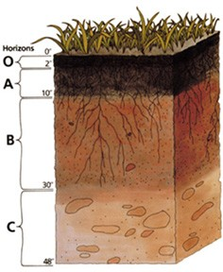
The B horizon or subsoil is where soluble minerals and clays accumulate. This layer is lighter brown and holds more water than the topsoil because of the presence of iron and clay minerals. There is less organic material.

C horizon
The C horizon is a layer of partially altered bedrock. There is some evidence of weathering in this layer, but pieces of the original rock are seen and can be identified.

Not all climate regions develop soils, and not all regions develop the same horizons. Some areas develop as many as five or six distinct layers, while others develop only very thin soils or perhaps no soils at all.
Figure 1.6. A soil profile is the complete set of soil layers. Each layer is called a horizon.

