Name _________________________ Date______________________

Soil Investigations

Investigation #1: Dry Soil
Procedure
Step 1. Place 1 teaspoon (tsp) of potting soil in the center circle of one copy of the graphic organizer and 1 tsp of local soil in the center circle of the other copy of the graphic organizer.

Step 2. Use a hand lens and a pencil to sort the soil components into the categories listed on the graphic organizer.

Step 3. Once both soil samples have been separated into their components, compare the results for the two types of soils.

Discussion Questions (Answer in Complete Sentences for Full Credit)

- In what ways are the two soil types similar? How are they different?

- Can you tell by visual inspection how well a soil will support plant growth? Why or why not?

Investigation #2 Soil Fractionation Lab
Description:
The sedimentation test is an easy way to measure the percent sand, slit, and clay in a soil sample. It is based on the fact that large, heavy particles will settle fastest, and small, light particles will settle slowest. The ammonia is used to separate the soil aggregates and keep the individual particles separated.

Materials:

- Smooth-sided Jar with lid
- Soil sample
- Ammonia & water
- Ruler
- Soil texture triangle

Procedures (Day 1)
- Place soil in jar until jar is ½ full of soil.
- Fill the jar with water, leaving ½” of air space at the top.
- Add 1-2 teaspoons of ammonia.
- Cap the jar.
- Shake jar for 5-10 minutes (Take turns in your group).
- Let jar stand.
- After about 5 minutes, you will begin to see the sand, silt, and clay separate.
- Let jar stand for at least 24 hours without disturbing it.

Results (Day 2):
- Using a ruler, measure the total depth of the soil sample in the jar in cm.
Record the results here: _________________

- Look for the different coloration in the separated layers of the soil sample. Each one of these is the sand, silt, and clay. Which layer is darkest? _________________

- The bottom layer is sand. Measure depth of the sand from the bottom and record here: __________

- Now measure the depth of the silt (middle layer). You will accomplish this by measuring the depth of the sand and silt together, then subtract the depth of the sand (see #6 below). The TOTAL measurement of sand and silt from the bottom of the jar is: _________________________________

- You already have the measurement needed to calculate the depth of the clay. You will put all numbers into a formula to calculate the amounts of each soil particle.

- Depth of sand & silt minus depth of sand equals silt.
_____________ - _____________ = ___________

- Total depth of soil minus depth of sand & silt equals clay
_____________ - _____________ = ___________

- Now we will calculate the percentages of sand, silt, and clay. You will use the following formulas to determine this:
Place your calculations in the space provided:
___________ ÷ ____________ x 100 = ___________ % Sand
___________ ÷ ____________ x 100 = ___________ % Silt
___________ ÷ ____________ x 100 = ___________ % Clay
Sand depth ÷ total depth x 100 = % sand
Silt depth ÷ total depth x 100 = % silt
Clay depth ÷ total depth x 100 = % clay

- Using a soil triangle (below), determine the type of soil of your sample.
Which type is it? ____________________________

Use the following soil texture triangle to answer questions about what kind of texture the soil has. Mark the percent measurements on each side, then use a ruler to locate where all of them intersect.
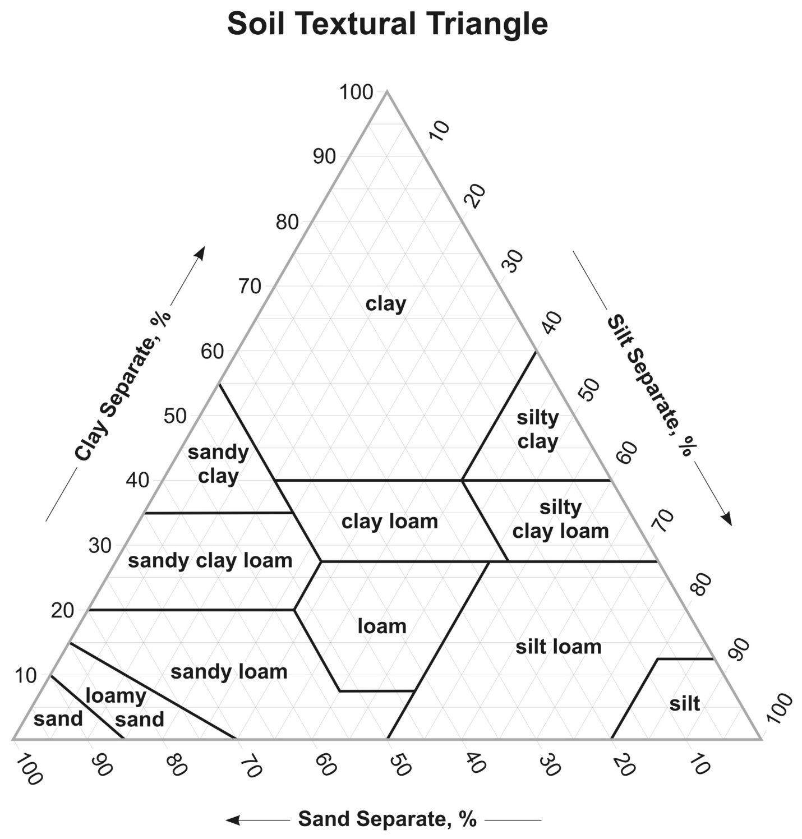

- If you have a soil with 35% clay, 30% silt, and 35% sand what kind of soil do you have? ___________________________________________

Each group was assigned a different soil type. We will collect class data and for you to record below:

Soil Type | % Sand | % Silt | % Clay
Potting soil

Local soil

Sand

Investigation #3: Soil and Air Space

Procedure
Step 1. Use the glass marking pencil to label three 50-milliliter (mL) test tubes “potting soil,” “local soil,” and “sand.”

Step 2. Place 20 mL of the appropriate soil into each test tube.

Step 3. Use a ruler to measure the height of the soil in the test tube. Make a mark near the top of the test tube at a position twice the height of the soil.

Step 4. Slowly add 20 mL of water to the tube containing the potting soil. Record your observations in the following table. Repeat, adding 20 mL of water to the tubes containing local soil and sand.

Soil Type | Height Before Water  A | Height After Water  B | Change in Height  (A-B)
Potting soil

Local soil

Sand

Discussion Questions (Answer in Complete Sentences for Full Credit)

- Why did the final water level differ among the three types of soil?

- Why is it important for plant growth that soils contain air space?

Investigation #4: Nitrogen in the Soil

Procedures

      - Put on safety goggles, do not remove them until the cleanup process is complete!!!
      - Fill test tube to line 7 with *Nitrogen Extracting Solution.
      - Add a ¼ teaspoon soil to the test tube.
      - Cap and mix gently for one minute.
      - Remove cap carefully and allow soil to settle.
      - Use a clean pipet to transfer the clear liquid to a second test tube. Make sure to squeeze bulb of pipet before inserting tip into liquid. Release bulb slowly to draw clear liquid into pipet. Try your best to not pull up any soil. Fill second tube to line 3 with liquid.
      - Add a ¼ teaspoon *Nitrogen Indicator Powder to soil extract in second tube. *If this touches your skin wash your hands immediately
      - Cap and gently mix. Wait 5 minutes for pink color to develop above the powder. (you can clean up the first test tube at this time).
      - Match test color with Nitrogen Color Chart (PINK). Record as Low, Medium or High. For your soil type below.

Results

Soil Type | Nitrogen Level  (Low, Medium or High?)
Potting soil

Local soil

Sand

Discussion Questions (Answer in Complete Sentences for Full Credit)

            - Which soil type had the most nitrogen?

            - Why is it important for soil to contain nitrogen?

- Based on nitrogen alone, which soil type would you grow a plant in?

