Amoeba Sisters Video Recap: Prokaryotes and Eukaryotes

1. The beginning of the video clip discusses potential challenges of a fungal infection and how antibiotics only work on prokaryote cells. Label the following with a P (prokaryote) or E (eukaryote).  Animal Cell  Plant Cell  Bacterial Cell  Fungus Cell | 2. What is the below statement referring to? This might be helpful when remembering eukaryotes!  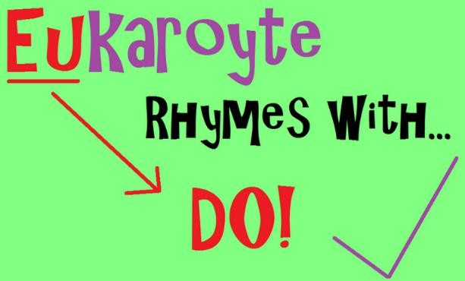
3. What is the below statement referring to? This might be helpful when remembering prokaryotes!  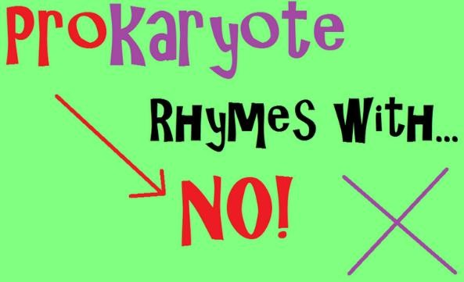 | 4. What is an organelle? Give two examples of  organelles that can be found within a cell.

9
Has a cell membrane

Includes bacteria
10
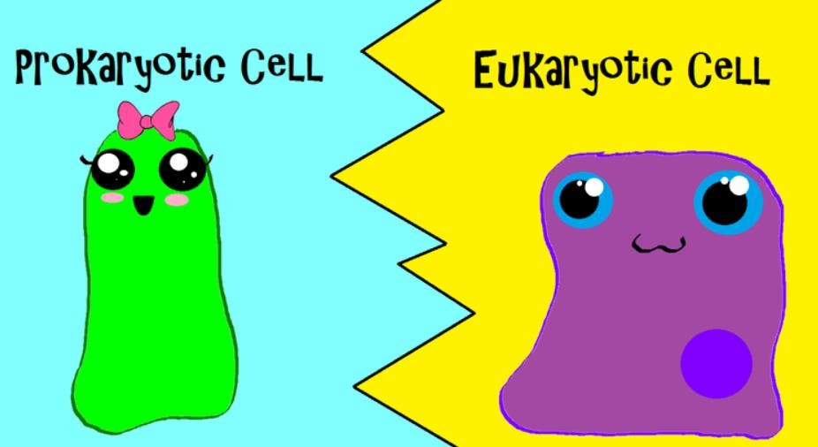
Now it’s time to match the fact with the right type of cell! Draw a line from each diamond to either the prokaryotic cell, the eukaryotic cell, or the “both” bubble (if it applies to both).
5

Has a Nucleus
6
Has membrane-bound organelles
7

Has DNA
8

Has ribosomes
APPLIES TO
BOTH
Antibiotics are effective on this cell type
11

