Answer the following questions related to photosynthesis and cellular respiration
- Autotrophs get energy from _________________________________________

- Heterotrophs get energy from _______________________________________

- What is the difference between ATP and ADP? What is released when ATP is changed to ADP?

- What is the equation for photosynthesis? Label the products and reactants. What gas is released into the air?

- What is the equation for cellular respiration? Label the products and reactants. What gas is released into the air?

- How are cellular respiration and photosynthesis dependent on each other?

- What organelle performs photosynthesis?

- What organelle performs cellular respiration?

- Why do plants have mitochondria?

- Compare and contrast aerobic and anaerobic cellular respiration.

- What is the process in box A and in box B?
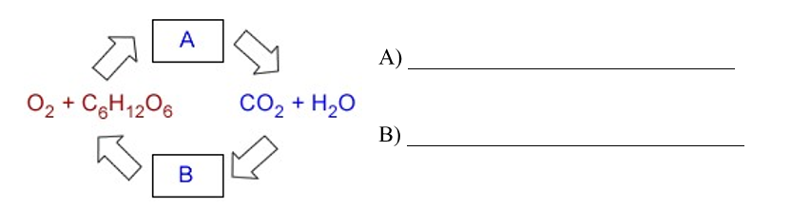
- Explain: Where do trees get their mass?

Circle the word(s) that best complete the statements

- Animals are considered (autotrophs/heterotrophs) while plants are considered (autotrophs/heterotrophs).

- Photosynthesis takes in (sunlight/glucose) and produces (sunlight/glucose).

- Cellular respiration takes in (ATP/glucose) and produces (ATP/glucose).

- Without carbon dioxide, plants (do/do not) produce glucose.

- (Photosynthesis/cellular respiration) cannot occur without sunlight.

