Genetic Variation
Sources of Genetic Variation
Sexual reproduction results in infinite possibilities of genetic variation. In other words, sexual reproduction results in offspring that are genetically unique. They differ from both parents and also from each other. This occurs for a number of reasons.
•When homologous chromosomes form pairs during prophase I of meiosis I, crossing-over can occur. Crossing- over is the exchange of genetic material between homologous chromosomes. It results in new combinations of genes on each chromosome.
•When cells divide during meiosis, homologous chromosomes are randomly distributed to daughter cells, and different chromosomes segregate independently of each other. This called is called independent assortment. It results in gametes that have unique combinations of chromosomes.
•In sexual reproduction, two gametes unite to produce an offspring. But which two of the millions of possible gametes will it be? This is likely to be a matter of chance. It is obviously another source of genetic variation in offspring. This is known as random fertilization.
All of these mechanisms working together result in an amazing amount of potential variation. Each human couple, for example, has the potential to produce more than 64 trillion genetically unique children. No wonder we are all different!

Crossing-Over
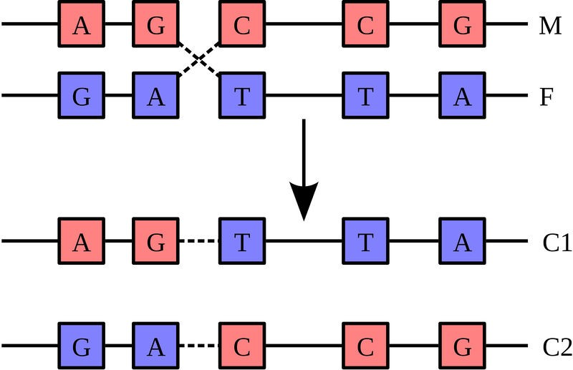
Crossing-over occurs during prophase I, and it is the exchange of genetic material between non-sister chromatids of homologous chromosomes. Recall during prophase I, homologous chromosomes line up in pairs, gene-for- gene down their entire length, forming a configuration with four chromatids, known as a tetrad. At this point, the chromatids are very close to each other and some material from two chromatids switch chromosomes, that is, the material breaks off and reattaches at the same position on the homologous chromosome (Figure 1.1). This exchange of genetic material can happen many times within the same pair of homologous chromosomes, creating unique combinations of genes. This process is also known as recombination.
Figure 1.1
Crossing-over. A maternal strand of DNA is shown in red. A paternal strand of DNA is shown in blue. Crossing over produces two chromosomes that have not previously existed. The process of re- combination involves the breakage and rejoining of parental chromosomes (M, F). This results in the generation of novel chromosomes (C1, C2) that share DNA from both parents

Independent Assortment and Random Fertilization
In humans, there are over 8 million configurations in which the chromosomes can line up during metaphase I of meiosis. It is the specific processes of meiosis, resulting in four unique haploid cells, that result in these many combinations. This independent assortment, in which the chromosome inherited from either the father or mother can sort into any gamete, produces the potential for tremendous genetic variation. Together with random fertilization, more possibilities for genetic variation exist between any two people than the number of individuals alive today. Sexual reproduction is the random fertilization of a gamete from the female using a gamete from the male. In humans, over 8 million (223) chromosome combinations exist in the production of gametes in both the male and female. A sperm cell, with over 8 million chromosome combinations, fertilizes an egg cell, which also has over 8 million chromosome combinations. That is over 64 trillion unique combinations, not counting the unique combinations produced by crossing-over. In other words, each human couple could produce a child with over 64 trillion unique chromosome combinations!

