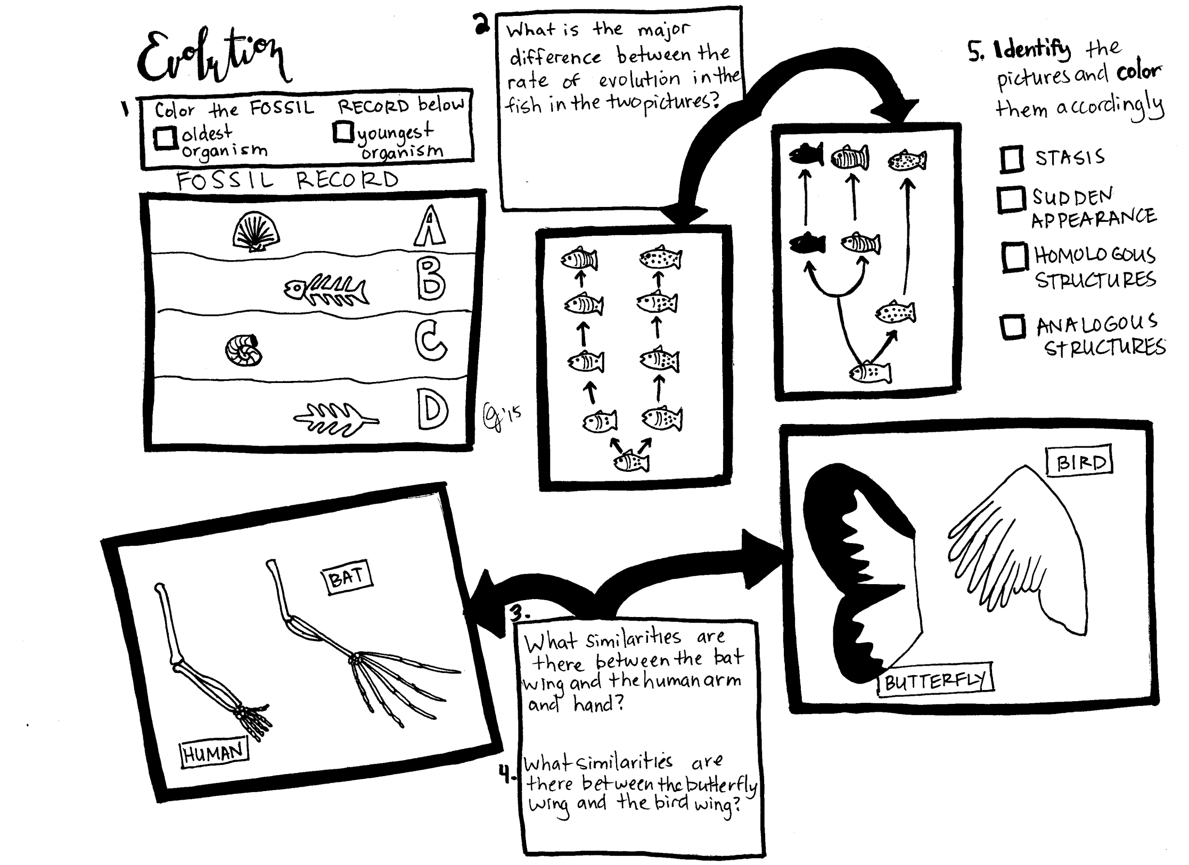

Which example (human/bat or bird/butterfly) is of convergent evolution?

Which example (human/bat or bird/butterfly) shows divergent evolution?

Punctuated Equilibrium

Gradualism

Analogous Structure

Homologous structure