Name:____________ Class Period:_______

Ecology Packet

Unit 5 Packet
Packet Grade
Biotic vs. Abiotic list and Concept Map | ____/10
Levels of Organization Chart | ____/10
Energy Pyramid with Questions | ____/20
Predator Prey game and Questions | ____/20
Succession Activity | ____/10
Landscape of Fear | ____/15

Stamps:
Biotic vs. Abiotic | Energy Pyramid with Questions | Predator Prey game and Questions | Succession Activity
Landscape of Fear |  |  | Study Guide

Abiotic vs. Biotic Concept Map

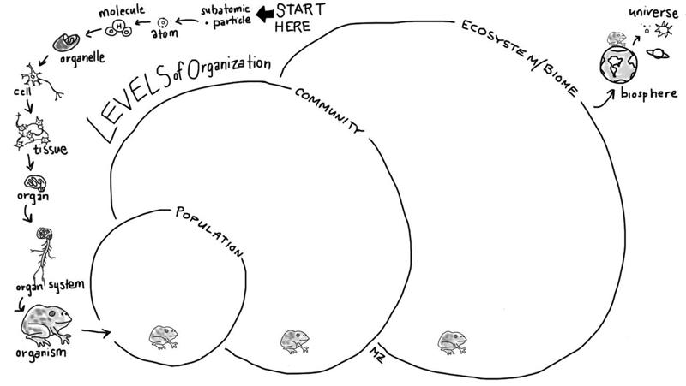

Name Date
C
H
E
F
O
O
R
S
C
I
E
O
N
I

Energy Flows and Matter Cycles Pyramid of Energy

Key
P = producers
C1 = primary consumers C2 = secondary consumers C3 = tertiary consumers
D = decomposers

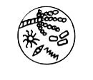
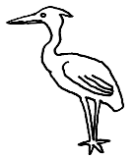
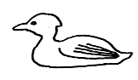
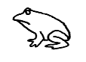
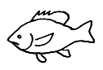
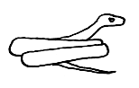
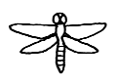
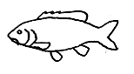
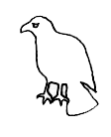
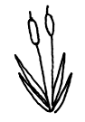
TROPHIC PYRAMID QUESTIONS

- Define trophic level.

- What is the ultimate energy for all life on Earth?

- Name the process used by autotrophs to convert energy into food. _______________________________

- The arrows on a trophic pyramid show that energy is being "lost" to the ecosystem. Where does the energy go?

- Herbivores are also called ______________________________.

- What are animals called that feed on herbivores? _____________________________________________

- Secondary consumers are eaten by _______________________________________________________.

- Can an organism fill more than one trophic level --- yes or no? Give an example.

- 100 lbs of corn are harvested from a farmers field. A hungry, hungry cow gets out of the pasture and eats all 100 lbs of the corn. The farmer gets mad, and in revenge, eats the cow. Unfortunately, the farmer is eaten by a large hungry mountain lion on her way back to the farmhouse (she was a very mean, nasty and evil farmer, so nobody minded). If we started with 100 lbs of food energy from the corn, how much does the mountain lion get?

- In all this growing and killing and eating and stuff, what do the decomposers get out of it?

- Draw a food web between the organisms below. Remember you can have more than one arrow going into or out of an organism.
decomposers
Invertebrates
Zooplankton
decomposers
Phytoplankton
Generation of Hares | Number of Lynx | # of Hares | Hares Eaten | Hares  Remaining | Lynx  Starved | Lynx  Surviving | Lynx  Offspring
1 | 1 | 3
2
3
4
5
6
7
8
9
10
11
12
13
14
15
16
17
18
19
20

1. Which 2 generations had the most number of Hares?

2. Which 2 generations had the most number of Lynx?

3. Which 2 generations had the most hares eaten?

4. Which 2 generations had the most Lynx starve?

5. From your graph, do the Lynx population peaks occur in the same generation as the peaks for the Hares? Which generations?

6. Describe at least two reasons for the pattern you observed above.

Activity: Identifying Stages of Ecological Succession

Directions
  - For each event, arrange the pictures in order of succession, and write their numbers or letters in order.
  - Identify each event as either Primary or Secondary.
  - What initially disturbed the environment?
  - Did life exist in this environment prior to the disturbance? Explain.
  - What pioneer species came first?
  - How did the pioneer species changed the environment for other living things to colonize?
  - Describe the organisms in the climax community.

Pond Event

1. ______ ______ ______ ______

2. ____________________________________

3. ____________________________________

4. ____________________________________
______________________________________
______________________________________

5. ______________________________________

6. ______________________________________
________________________________________
________________________________________
7. ______________________________________
________________________________________
________________________________________
Forest Event

1. ______ ______ ______ ______

2. ____________________________________

3. ____________________________________

4. ____________________________________
______________________________________
______________________________________

5. ______________________________________

6. ______________________________________
________________________________________
________________________________________
7. ______________________________________
________________________________________
________________________________________
Volcanic Event

1. ______ ______ ______ ______

2. ____________________________________

3. ____________________________________

4. ____________________________________
______________________________________
______________________________________

5. ______________________________________

6. ______________________________________
________________________________________
________________________________________
7. ______________________________________
________________________________________
________________________________________
Biotic | Abiotic
Landscape of Fear

