Digestive System Organs

Douglas Wilkin, Ph.D. Jean Brainard, Ph.D.

Say Thanks to the Authors
Click http://www.ck12.org/saythanks
(No sign in required)
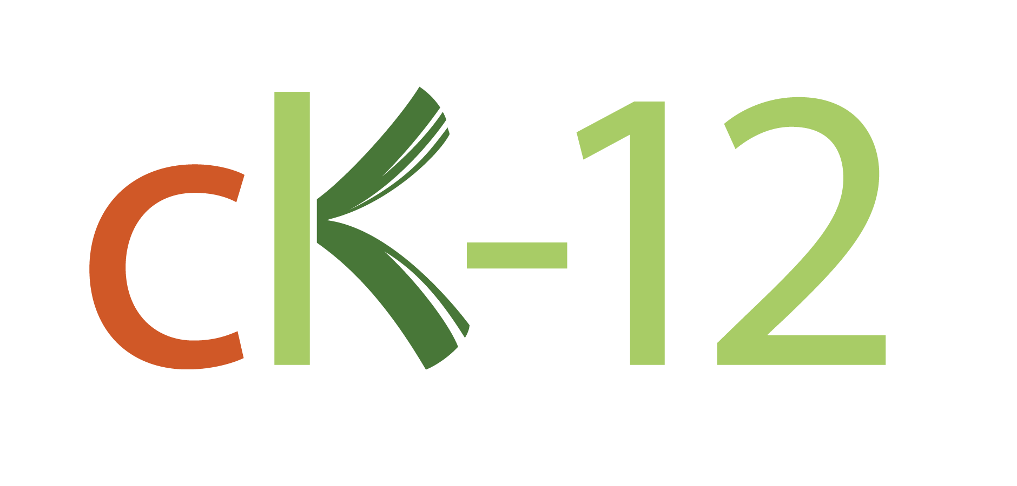

To access a customizable version of this book, as well as other interactive content, visitwww.ck12.org

CK-12 Foundation is a non-profit organization with a mission to reduce the cost of textbook materials for the K-12 market both in the U.S. and worldwide. Using an open-source, collaborative, and web-based compilation model, CK-12 pioneers and promotes the creation and distribution of high-quality, adaptive online textbooks that can be mixed, modified and printed (i.e., the FlexBook® textbooks).

Copyright © 2017 CK-12 Foundation, www.ck12.org

The names “CK-12” and “CK12” and associated logos and the terms “FlexBook®” and “FlexBook Platform®” (collectively “CK-12 Marks”) are trademarks and service marks of CK-12 Foundation and are protected by federal, state, and international laws.

Any form of reproduction of this book in any format or medium, in whole or in sections must include the referral attribution link http://www.ck12.org/saythanks (placed in a visible location) in addition to the following terms.

Except as otherwise noted, all CK-12 Content (including CK-12 Curriculum Material) is made available to Users in accordance with the Creative Commons Attribution-Non-Commercial 3.0 Unported (CC BY-NC 3.0) License (http://creativecommons.org/ licenses/by-nc/3.0/), as amended and updated by Creative Com- mons from time to time (the “CC License”), which is incorporated herein by this reference.

Complete terms can be found athttp://www.ck12.org/about/ terms-of-use.

Printed: February 17, 2017
AUTHORS
Douglas Wilkin, Ph.D. Jean Brainard, Ph.D.

www.ck12.orgChapter 1. Digestive System Organs

CHAPTER
1
Digestive System Organs

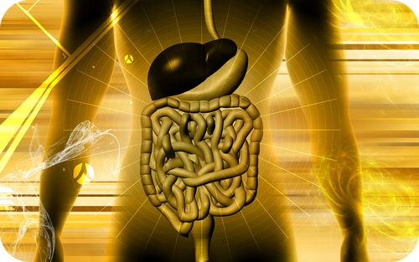

Specifically, our energy comes from what?

The respiratory and circulatory systems work together to provide cells with the oxygen they need for cellular respiration. Cells also need glucose for cellular respiration. Glucose is a simple sugar that comes from the food we eat. To get glucose from food, digestion must occur. This process is carried out by the digestive system.

Overview of the Digestive System

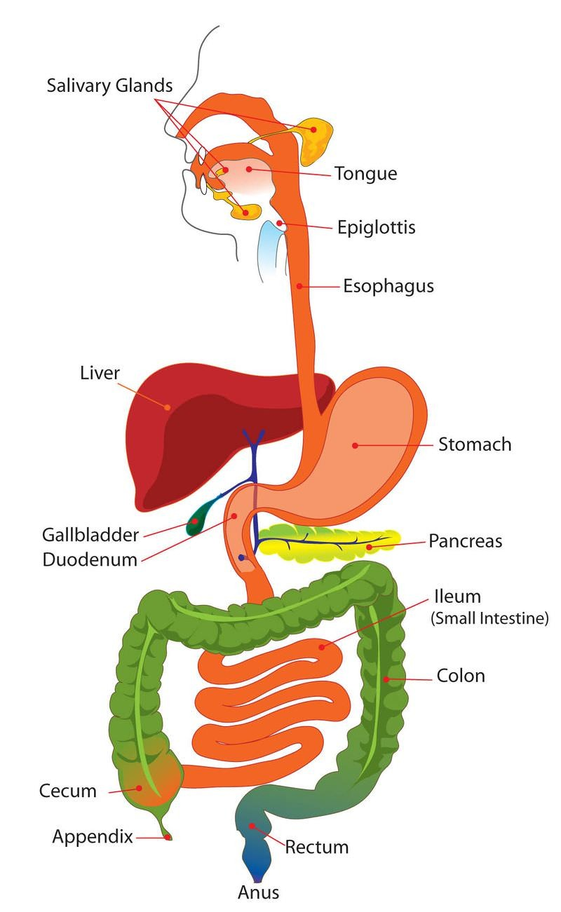
The digestive system consists of organs that break down food and absorb nutrients such as glucose. Organs of the digestive system are shown in Figure 1.1. Most of the organs make up the gastrointestinal tract. The rest of the organs are called accessory organs.

The Gastrointestinal Tract

The gastrointestinal (GI) tract is a long tube that connects the mouth with the anus. It is more than 9 meters (30 feet) long in adults and includes the esophagus, stomach, and small and large intestines. Food enters the mouth, passes through the other organs of the GI tract, and then leaves the body through the anus.

The organs of the GI tract are lined with mucous membranes that secrete digestive enzymes and absorb nutrients. The organs are also covered by layers of muscle that enable peristalsis. Peristalsis is an involuntary muscle contraction that moves rapidly along an organ like a wave (see Figure 1.2).

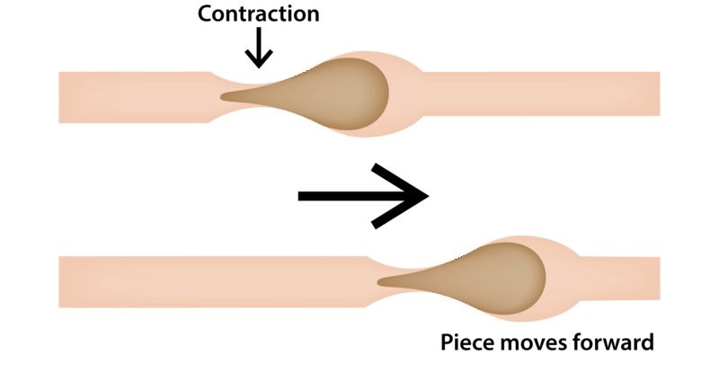

Figure 1.2 Figure 1.1

Accessory Organs of Digestion

Other organs involved in digestion include the liver, gall bladder, and pancreas. They are called accessory organs because food does not pass through them. Instead, they secrete or store substances needed for digestion.

The digestive system has three main functions: digestion of food, absorption of nutrients, and elimination of solid food waste. Digestion is the process of breaking down food into components the body can absorb. It consists of two types of processes: mechanical digestion and chemical digestion.

- Mechanical digestion is the physical breakdown of chunks of food into smaller pieces. This type of digestion takes place mainly in the mouth and stomach.
- Chemical digestion is the chemical breakdown of large, complex food molecules into smaller, simpler nutrient molecules that can be absorbed by the blood. This type of digestion begins in the mouth and stomach but occurs mainly in the small intestine.

After food is digested, the resulting nutrients are absorbed. Absorption is the process in which substances pass into the bloodstream, where they can circulate throughout the body. Absorption of nutrients occurs mainly in the small intestine. Any remaining matter from food that cannot be digested and absorbed passes into the large intestine as waste. The waste later passes out of the body through the anus in the process of elimination.

Summary

•The digestive system consists of organs that break down food, absorb nutrients, and eliminate waste.
•The breakdown of food occurs in the process of digestion.

Review

1.What organs make up the gastrointestinal tract? What are the accessory organs of digestion? 2.Describe peristalsis and its role in digestion.
3.Define mechanical and chemical digestion.

References

- Mariana Ruiz Villarreal (User:LadyofHats/Wikimedia Commons).Major componentsofthedigestive system
. Public Domain
- Zachary Wilson.Peristalsisillustration. CC BY-NC 3.0

