Name:_______________________ Cell Quiz Study Guide Date of Quiz:_______________________
Directions: Look through your notes and worksheets to review the below topics for the quiz.

- List the 3 principles of the Cell Theory.
  - ________________________________________________________________________________
  - ________________________________________________________________________________
  - ________________________________________________________________________________

- Compare and contrast prokaryotes and eukaryotes.

Prokaryotes Both Eukaryotes
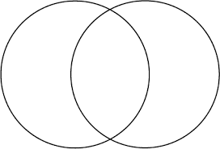

Match the following functions to the correct organelle.

- Mitochondria
- Cell membrane
- Cell wall
- Golgi apparatus
- Endoplasmic reticulum (ER)
- Ribosome
- Vacuole
- Chloroplast
- Lysosome
- Nucleus

- ____ This organelle provides a rigid boarder for the plant cell
- ____ Organelle is selectively permeable and allows substances to go in/out of cell
- ____ Organelle helps transport proteins and lipids within the cell
- ____ This organelle stores water and nutrients for the cell.
- ____ This organelle holds the DNA (genetic information) of the cell
- ____ This organelle creates energy for the cell using sugars
- ____ This organelle packages and sends proteins
- ____ Organelle that makes proteins
- ____ Organelle where photosynthesis takes place
- ____ This organelle is the garbage disposal of the cell

- List 3 differences between plant and animal cells.
  - ____________________________________________________________________________________
  - ____________________________________________________________________________________
  - ____________________________________________________________________________________

- Identify the organelles from the below diagrams:

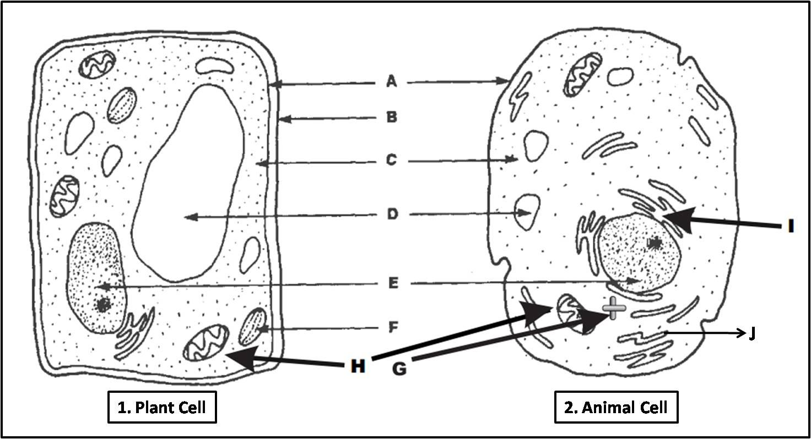

  - ________________________________
  - ________________________________
  - ________________________________
  - ________________________________
  - ________________________________
  - ________________________________
  - ________________________________
  - ________________________________
  - ________________________________
  - ________________________________

- Label the diagrams below as either eukaryotic or prokaryotic.
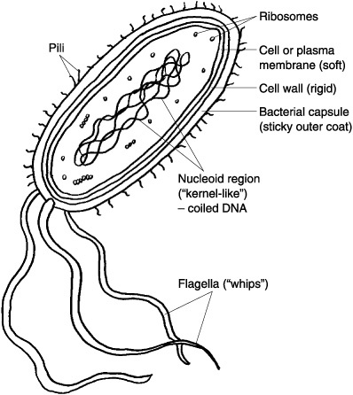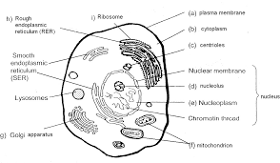
Diagram 1 Diagram 2

_____________________ _______________________

- Explain how you know the difference between prokaryotic and eukaryotic cells in 1 to 2 sentences.

