Date of My Quiz:_________________ Biochemistry Quiz Study Guide
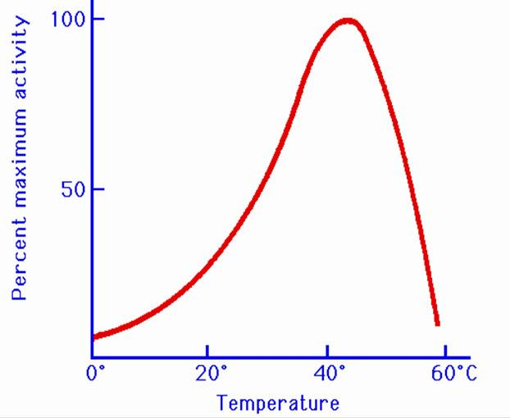
Directions: Answer on a separate sheet of paper using the amoeba sisters video worksheet, Frayer model vocabulary, and page 81 and 85-86 of your lab book, as well as notes taken in class.
- List all four macromolecules and their monomers.
- What are the main functions for each macromolecule?
- What are enzymes?
- Compare and contrast catabolic and anabolic enzymes?
- Explain how enzymes work? (Be able to use the following vocabulary: substrate, activation energy, active site, enzyme/catalyst, product, macromolecule, and monomer)
- Why are enzymes considered specific?
- Describe how saliva chemically breaks down starches.
- Analyze how temperature affects enzyme activity.
- What is the optimum temperature for the enzyme in the graph to the right?
- Identify what macromolecule/monomer Benedicts, Iodine, and Biuret solution test for.

Date of My Quiz:_________________ Biochemistry Quiz Study Guide
Directions: Answer on a separate sheet of paper using the amoeba sisters video worksheet, Frayer model vocabulary, and page 81 and 85-86 of your lab book, as well as notes taken in class.
- List all four macromolecules and their monomers.
- What are the main functions for each macromolecule?
- What are enzymes?
- Compare and contrast catabolic and anabolic enzymes?
- Explain how enzymes work? (Be able to use the following vocabulary: substrate, activation energy, active site, enzyme/catalyst, product, macromolecule, and monomer)
- Why are enzymes considered specific?
- Describe how saliva chemically breaks down starches.
- Analyze how temperature affects enzyme activity.
- What is the optimum temperature for the enzyme in the graph to the right?
- Identify what macromolecule/monomer Benedicts, Iodine, and Biuret solution test for.

